2021/ 2022 Calendar
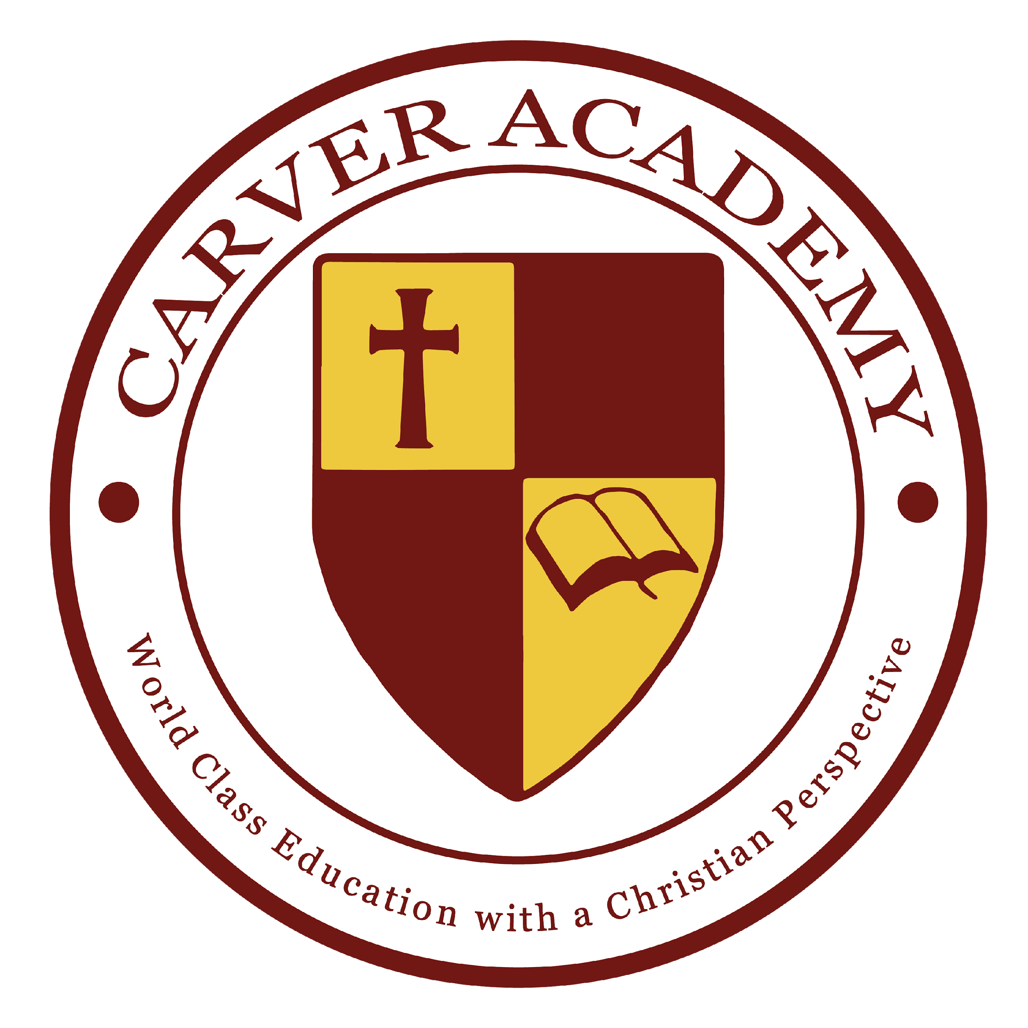

September
2 Orientation 7PM church auditorium (parents only please)
7 First day of school
22-23 CASHO Trade Show- Closed
24 Friday Fun Day Theme: Mismatch
September Birthday Celebrations

October
8 Professional Development – Closed
11 Columbus Day – Closed
29 Friday Fun Day Theme: Career Day
October Birthday Celebrations

November
2 Professional Development – Closed
5 End of 1st Quarter
11 Veteran's Day – Closed
19 Report Cards
19 November Birthday Celebrations
24 Grandparent’s day
Early Dismissal for Thanksgiving*
25-26 Thanksgiving Recess – Closed

December

17 December Birthday Celebrations
22 Friday Fun Day Theme: Pajama Day
22 Early Dismissal for Christmas Break*
22 - Jan 3 Christmas Break – Closed

*Early Dismissals are at 12:00 Noon
No Extended Care for Early Dismissals
**Snow cancellations, delays, and early
dismissals follow Meriden Schools
***Academy Special Event Attire Required

January 2021
4 School Resumes
14 End of 2nd Quarter
17 Martin Luther King Day – Closed
28 Friday Fun Day Theme: 80’s Throwback
January Birthday Celebrations
28 Report Cards

February
11 100th Day of School –
Dress Like You Are 100 Years Old
21-25 Winter Break – School Closed
25 February Birthday Celebrations

March
25 March Birthday Celebrations
Friday Fun Day Theme: Camo
End of 3rd Quarter

April
15 Good Friday – Closed
18-22 Spring Break – School Closed
25-29 Standardized Testing, 4th-6th only
14 Report Cards
29 Friday Fun Day Theme: Crazy Hair Day
April Birthday Celebrations

May

20 Friday Fun Day Theme: Sports
27 May-August Birthday Celebrations
30 Memorial Day – Closed

June
3 End of 4th Quarter
7 Student Award Celebration 6:30 PM
7 Last Day of School, Early Dismissal*
8 Family Fun Day at Lake Compounce

